- *Greetings
- *Gathering Music
TFWS 2152, Change my heart O God
Change my heart, O God. Make it ever true. Change my heart, O God.
May I be like you. You are the Potter, I am the clay. Mold me and make me. This is what I pray.

W&S #3002, Blessed Be Your Name
Blessed be your name in the land that is plentiful, where the streams of abundance flow, blessed be your name. And blessed be your name when I’m found in the desert place, though I walk through the wilderness, blessed be your name.

[Refrain] Every blessing you pour out I’ll, turn back to praise, and when the darkness closes in, Lord, still I will say. Blessed be the name of the Lord, blessed be your name. Blessed be the name of the Lord, Blessed be your glorious name.

Blessed be your name when the sun’s shining down on me, when the world’s all as it should be, blessed be your name. Blessed be your name on the road marked with suffering, though there’s pain in the offering, blessed be your name [Refrain].

- *Call to Worship
Leader: We are chosen children of God, bound together by the Holy Spirit.
People: We belong to God, and through God, we belong to one another.

Leader: The Spirit empowers us to live as imitators of Christ in love of God, neighbor, self, and all creation.
People: We belong to God, and through God, we learn to love one another.

Leader: The Spirit inspires us to receive God’s Word with joy in a world that rejects the good news.
People: We belong to God, and through God, we live in joy with one another.

Leader: Come, let us worship in the assurance of God’s love that chooses us, empowers us, and inspires us to live as the family of Christ.
People: We come to worship God in the assurance that we belong to God, and through God, we belong to one another. Amen.

- Prayer of Confession & Words of Assurance
God of Grace, we know that you have chosen us,
but we often forget that you have also chosen others.
You call us to be imitators of Christ,
yet many times we are imitators of the world.
You challenge us to turn from our idols,
but we are tempted to turn back to them again and again.
Rescue us, Lord, from ourselves.
Show us your way.
Guide our every action, that we may live as you call us to live.

Beloved children of God, receive this good news:
God loves us, chooses us, forgives us, and renews us
to live in love and service of God and neighbor.
In the name of Jesus Christ, you are forgiven.
Glory to God! Amen.

- *Hymn UMH #188, Christ Is the World’s Light (1, 2 & 4)

1. Christ is the world's light, Christ and none other; born in our darkness, he became our brother. If we have seen him, we have seen the Father: Glory to God on high!
2. Christ is the world's peace, Christ and none other; no one can serve him and despise another. Who else unites us, one with God the Father? Glory to God on high!
4. Give God the glory, God and none other; give God the glory, Spirit, Son and Father; give God the glory, God with us, our brother: Glory to God on high!

- Faith in Action (see the insert)

- Scripture Lesson Isaiah 49:1-7

- Children’s Time
(As children come forward) “Yes, Jesus loves us (x3). The Bible tells us so.”
(As children return) “God is watching over you…each day.”

- Sermon “An Arrow and a Quiver” Pastor Sunmin

- *Offering UMH #94, Praise God from Whom All Blessings Flow
Praise God from whom all blessings flow; Praise God, all creatures here below: Alleluia! Alleluia! Praise God, the source of all our gifts! Praise Jesus Christ, whose power uplifts! Praise the Spirit, Holy Spirit! Alleluia! Alleluia! Alleluia!

- *Prayer of Dedication
Gracious God, receive these gifts as signs of our gratitude and our willingness to be witnesses to your grace. May our shared life together always point to Christ, whose love calls and sends us. Amen.

- Prayer Concern
“Lord, in Your Mercy, Hear Our Prayer.”

- Pastoral Prayer & the Lord’s Prayer

- *Hymn of Your Choice (First Shout, First Sung basis)

- *Benediction & Postlude

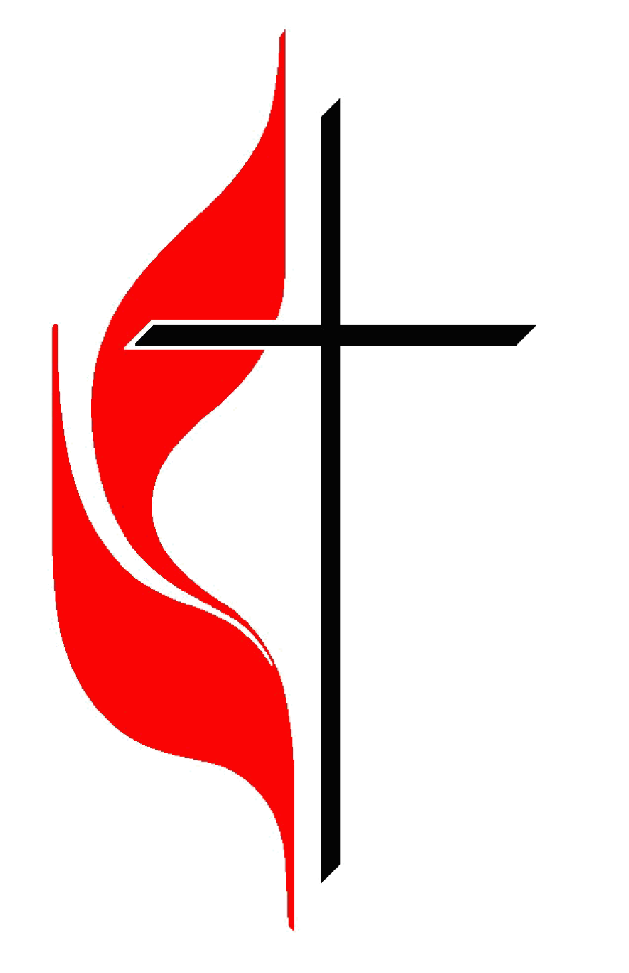
The United Methodist Church of Newton
430 Walnut St., Newton, MA 02460 | 617-244-0275

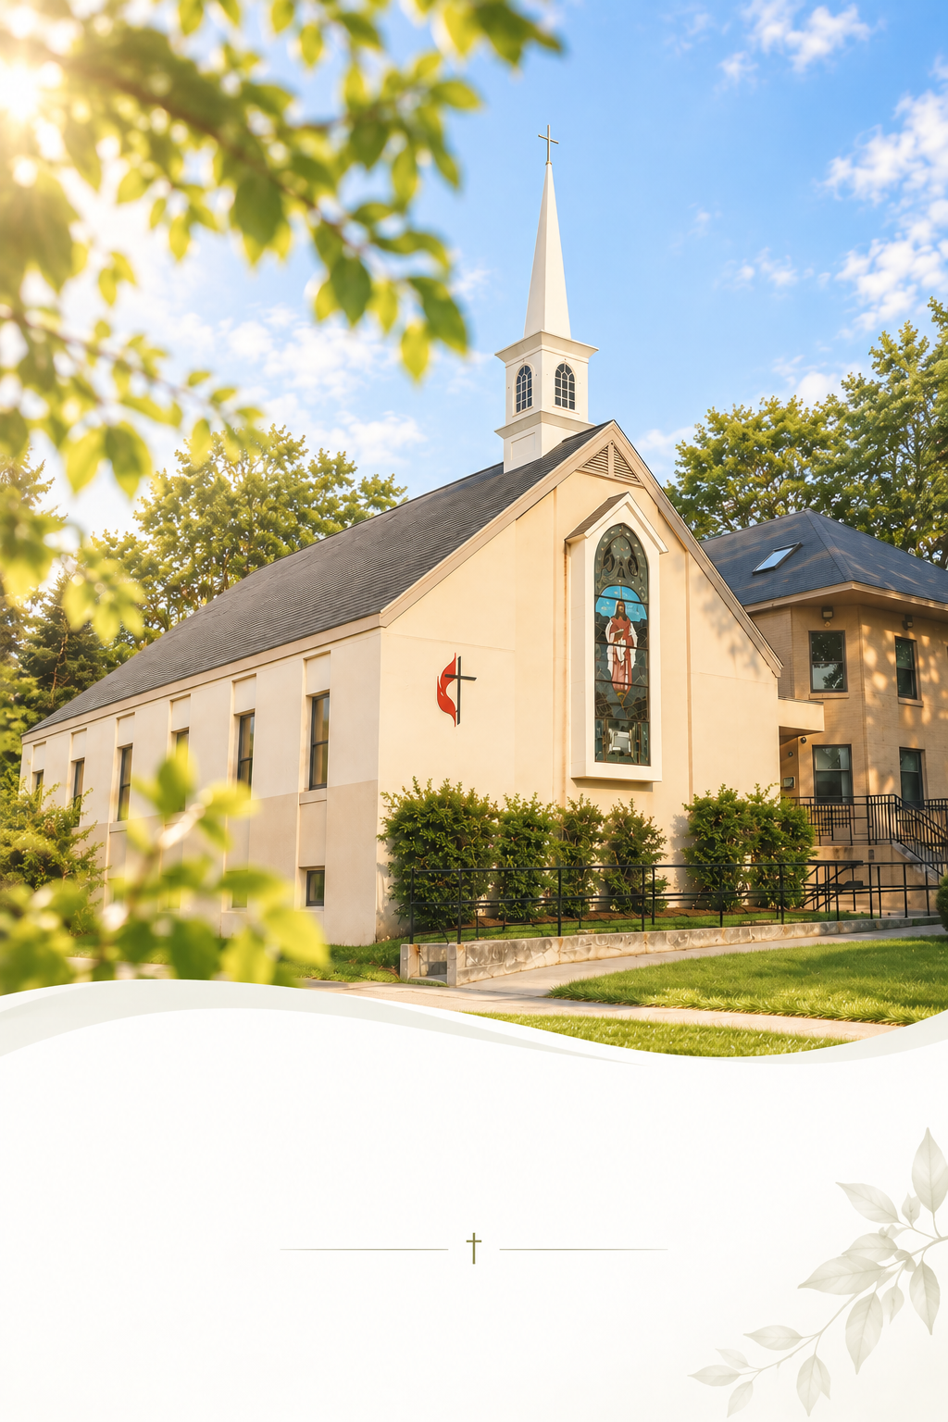

October 18, 2026
Sunday Worship 10:30AM

Faith in Action

Mission Statement
We act as disciples for Christ by freely sharing our resources with our community and by serving those who are lonely and in need. We support each other in growing our faith and seeking meaningful ways to share God’s grace with more people.

- Every 1st Sat @ 8:30 AM: Men’s Walk & Breakfast

- Every Sun. 9:40 AM: Music Rehearsal. Anyone who can play an instrument or sing can join us!

- You are invited to our coffee hour in the fellowship downstairs!
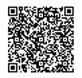
- Online Offering is available! Take a picture of the QR code, or visit give.tithe.ly and search for “United Methodist Church of Newton -430 Walnut St, Newtonville.”

- Need a prayer? Please remain in the sanctuary after the service. The pastor will pray with you.

- Want to be a member of the church? Talk to the pastor.

- First Free Public Seminar by Newton-Boston Korean United Methodist Church - "Understanding Alzheimer’s disease and related dementias” by Hyun-Sik Yang, MD.
In Korean – Sun. Oct 25. 2:30 PM.
In English- Sun. Nov 8. 2:30 PM.

- 2026 Church Conference – Wed. Nov 11th. 7 PM (800 Highland Ave, Needham, MA 02494)

Faith in Action

Mission Statement
We act as disciples for Christ by freely sharing our resources with our community and by serving those who are lonely and in need. We support each other in growing our faith and seeking meaningful ways to share God’s grace with more people.

- Every 1st Sat @ 8:30 AM: Men’s Walk & Breakfast

- Every Sun. 9:40 AM: Music Rehearsal. Anyone who can play an instrument or sing can join us!

- You are invited to our coffee hour in the fellowship downstairs!
- Online Offering is available! Take a picture of the QR code, or visit give.tithe.ly and search for “United Methodist Church of Newton -430 Walnut St, Newtonville.”

- Need a prayer? Please remain in the sanctuary after the service. The pastor will pray with you.

- Want to be a member of the church? Talk to the pastor.

- First Free Public Seminar by Newton-Boston Korean United Methodist Church - "Understanding Alzheimer’s disease and related dementias” by Hyun-Sik Yang, MD.
In Korean – Sun. Oct 25. 2:30 PM.
In English- Sun. Nov 8. 2:30 PM.

- 2026 Church Conference – Wed. Nov 11th. 7 PM (800 Highland Ave, Needham, MA 02494)

