- *Greetings
- *Gathering Music
There Is None like You
There is none like You. No one else can touch my heart like You do.
I can search for all eternity long, And find, there is none like You.
Your mercy flows like a river so wide. And healing comes from Your hand.
Suffering children are safe in Your arms. There is none like You.

By Gentle Powers
1. By gentle powers lovingly surrounded, by wonderous peace always around us all. Taking a journey with you all God’s people. Forever with you on this path to God.
2. The little candle that the Lord has lit-, breaks through-- the dar-kness and burns. May we all come together in that li-ght and shine upon the world as one.
[refrain] By gentle powers lovingly surrounded with patience we’ll endure, let come what may. God is with us at night and in the morning. And certainly on every future day.
3. When silence spreads deeply around us, let us- hear the heart- warming song. And lead us once again to become one, on this- night where your- light- shines [refrain].

W&S #3152, Welcome
"Let's walk together for a while and ask where we begin.
To build a world where love can grow and hope can enter in.
To be the hands of healing and to plant the seed of peace,
Singing welcome, welcome to this place.
You're invited to come and know God's grace.
All are welcome the love of God to share,
'cause all of us are welcome here; all are welcome in this place."

- *Passing the Peace of Christ

- *Call to Worship
Leader: Family of God, rejoice! The kingdom of God is all around us!
People: We gather to encourage one another to keep awake and watch, for the kingdom of God is at hand.
Leader: Sometimes we grow weary in the waiting, and we wonder if we are watching and working for nothing.
People: We gather to encourage one another to keep awake and watch, for the kingdom of God is at hand.
Leader: Sometimes God surprises, and we are overwhelmed by joy and wonder at all God is doing among us.
People: We gather to encourage one another to keep awake and watch, for the kingdom of God is at hand.
Leader: Family of God, whether you are weary or energized, worried or wonder-filled, rejoice! The kingdom of God is all around us!
People: We gather to encourage one another to keep awake and watch, for the kingdom of God is at hand. Thanks be to God! Amen.

- Prayer of Confession & Words of Assurance
Jesus Christ, often we forget you in the cares of everyday life,
but you are there with us: Christ, have mercy.
Forgive us all our sins, Lord, and make us look for your presence.
Walk with us and lead us to the feast of everlasting life.
God’s grace is abundant and meets us where we are
Forgiving us and inspiring us to stay awake and
aware of all God is doing among us!
In the name of Jesus Christ, we are forgiven. Glory to God! Amen.

- *Hymn UMH #399, Take My Life, and Let It Be
1. Take my life, and let it be consecrated, Lord, to thee.
Take my moments and my days; let them flow in ceaseless praise.
Take my hands, and let them move at the impulse of thy love.
Take my feet, and let them be swift and beautiful for thee.
2. Take my voice, and let me sing always, only, for my King.
Take my lips, and let them be filled with messages from thee.
Take my silver and my gold; not a mite would I withhold.
Take my intellect, and use every power as thou shalt choose.
3. Take my will, and make it thine; it shall be no longer mine.
Take my heart, it is thine own; it shall be thy royal throne.
Take my love, my Lord, I pour at thy feet its treasure-store.
Take myself, and I will be ever, only, all for thee.

- Faith in Action (see the insert)

- Scripture Lesson Matthew 25:1-13
- Children’s Time
(As children come forward) “Yes, Jesus loves us (x3). The Bible tells us so.”
(As children return) “God is watching over you…each day.”

- Sermon “Foolish Assumptions” Pastor Sunmin

- *Offering UMH #94, Praise God from Whom All Blessings Flow
Praise God from whom all blessings flow; Praise God, all creatures here below: Alleluia! Alleluia! Praise God, the source of all our gifts! Praise Jesus Christ, whose power uplifts! Praise the Spirit, Holy Spirit! Alleluia! Alleluia! Alleluia!

- *Prayer of Dedication
Watchful God, use these offerings and our willing spirits to bring light, hope, and welcome to your children.
Keep us awake to your presence and faithful in your service, through Christ our Lord. Amen.

- The Lord’s Supper UMH #9.
- Prayer of the People
“Lord, in Your Mercy, Hear Our Prayer.”

- Pastoral Prayer & the Lord’s Prayer

- *Hymn of Your Choice (First Shout, First Sung basis)

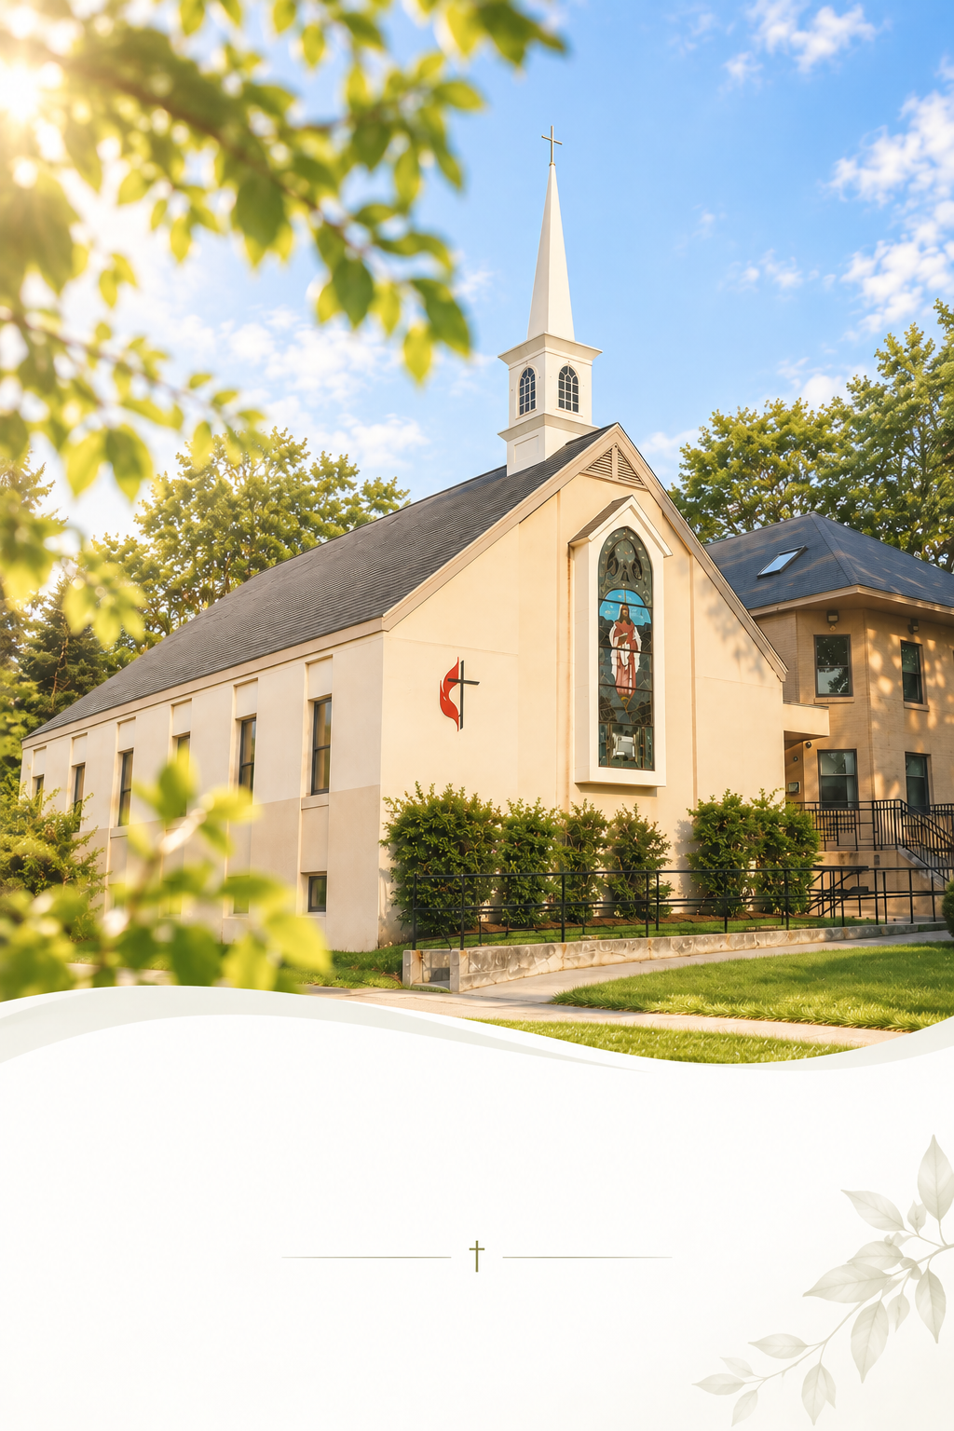
- *Benediction & Postlude

November 8, 2026
Sunday Worship 10:30AM


The United Methodist Church of Newton
430 Walnut St., Newton, MA 02460 | 617-244-0275

Faith in Action

Mission Statement
We act as disciples for Christ by freely sharing our resources with our community and by serving those who are lonely and in need. We support each other in growing our faith and seeking meaningful ways to share God’s grace with more people.

- We are part of New England Metro-West Cooperative Parish. (https://www.umcnewton.org/about-1-1)

- Every 1st Sat @ 8:30 AM: Men’s Walk & Breakfast

- Every Sun. 9:40 AM: Music Rehearsal. Anyone who can play an instrument or sing can join us!

- You are invited to our coffee hour in the fellowship downstairs!

- Online Offering is available! Take a picture of the QR code, or visit give.tithe.ly and search for “United Methodist Church of Newton -430 Walnut St, Newtonville.”

- Need a prayer? Please remain in the sanctuary after the service. The pastor will pray with you.

- Want to be a member of the church? Talk to the pastor.

- First Free Public Seminar by Newton-Boston Korean United Methodist Church - "Understanding Alzheimer’s disease and related dementias” by Hyun-Sik Yang, MD.
In English - Sun. Nov 8. 2:30 PM.

- 2026 Church Conference – Wed. Nov 11th. 6:30 PM (800 Highland Ave, Needham, MA 02494)

- Pulpit Exchange. Sun. Dec 6. Welcome Pastor Cho!

- Please put in your Pledge Card in the Offering Box.

- Worship Seminar – Tue. Nov 10. 7 PM. “Extending the Table: A Pathway to Renewal in the Local Church.”

Faith in Action

Mission Statement
We act as disciples for Christ by freely sharing our resources with our community and by serving those who are lonely and in need. We support each other in growing our faith and seeking meaningful ways to share God’s grace with more people.

- We are part of New England Metro-West Cooperative Parish. (https://www.umcnewton.org/about-1-1)

- Every 1st Sat @ 8:30 AM: Men’s Walk & Breakfast

- Every Sun. 9:40 AM: Music Rehearsal. Anyone who can play an instrument or sing can join us!

- You are invited to our coffee hour in the fellowship downstairs!
- Online Offering is available! Take a picture of the QR code, or visit give.tithe.ly and search for “United Methodist Church of Newton -430 Walnut St, Newtonville.”

- Need a prayer? Please remain in the sanctuary after the service. The pastor will pray with you.

- Want to be a member of the church? Talk to the pastor.

- First Free Public Seminar by Newton-Boston Korean United Methodist Church - "Understanding Alzheimer’s disease and related dementias” by Hyun-Sik Yang, MD.
In English - Sun. Nov 8. 2:30 PM.

- 2026 Church Conference – Wed. Nov 11th. 6:30 PM (800 Highland Ave, Needham, MA 02494)

- Pulpit Exchange. Sun. Dec 6. Welcome Pastor Cho!

- Please put in your Pledge Card in the Offering Box.

- Worship Seminar – Tue. Nov 10. 7 PM. “Extending the Table: A Pathway to Renewal in the Local Church.”

