- *Greetings
- *Gathering Music
W&S #3038, Mighty to Save
(1) Everyone needs compassion Love that's never failing Let mercy fall on me Everyone needs forgiveness The kindness of a saviour The hope of nations
(Chorus) Saviour He can move the mountains My God is mighty to save He is mighty to save Forever Author of salvation He rose and conquered the grave Jesus conquered the grave

(2) So take me as You find me All my fears and failures Fill my life again I give my life to follow Everything I believe in Now I surrender

(Bridge) Shine your light And let the whole world see We're singing for the glory Of the risen King Jesus

W&S #3152, Welcome
"Let's walk together for a while and ask where we begin.
To build a world where love can grow and hope can enter in.
To be the hands of healing and to plant the seed of peace,
Singing welcome, welcome to this place.
You're invited to come and know God's grace.
All are welcome the love of God to share,
'cause all of us are welcome here; all are welcome in this place."

- *Call to Worship
Leader: We are chosen children of God, bound together by the Holy Spirit.
People: We belong to God, and through God, we belong to one another.

Leader: When we struggle with damaged trust and the need to repair our relationships with God and one another, when we are called to go against the social current to build communities of mercy and justice, we remember.
People: We belong to God, and through God, we belong to one another.

Leader: Come, let us worship God whose grace surrounds us when we feel tested and tried, empowering us to remain faithful disciples of Jesus Christ when we face chaos, division, injustice, and hardship.
People: We come to worship God who chooses us, empowers us, and inspires us to live as the Body of Christ in a broken and hurting world. Amen.

- Prayer of Confession & Words of Assurance
Almighty God, You love us, but we have not loved you; you call, but we have not listened. We walk away from neighbors in need, wrapped up in our own concerns. Holy God, help us to face up to ourselves, so that, as you move toward us in mercy, we may repent, turn to you, and receive mercy; through Jesus Christ.

Let us receive this good news: God, who tests our hearts, gives us abundant grace to turn from sin and back to God again and again and again.
In the name of Jesus Christ, we are forgiven. Glory to God! Amen.

- *Hymn UMH #399, Take My Life, and Let It Be
1. Take my life, and let it be consecrated, Lord, to thee.
Take my moments and my days; let them flow in ceaseless praise.
Take my hands, and let them move at the impulse of thy love.
Take my feet, and let them be swift and beautiful for thee.
2. Take my voice, and let me sing always, only, for my King.
Take my lips, and let them be filled with messages from thee.
Take my silver and my gold; not a mite would I withhold.
Take my intellect, and use every power as thou shalt choose.
3. Take my will, and make it thine; it shall be no longer mine.
Take my heart, it is thine own; it shall be thy royal throne.
Take my love, my Lord, I pour at thy feet its treasure-store.
Take myself, and I will be ever, only, all for thee.

- Faith in Action (see the insert)

- Scripture Lesson Second Corinthians 8:1-5

- Stewardship Moment Rhanna Kidwell
- Children’s Time
(As children come forward) “Yes, Jesus loves us (x3). The Bible tells us so.”
(As children return) “God is watching over you…each day.”

- Sermon “Give Your Heart to God” Pastor Sunmin

- *Offering UMH #94, Praise God from Whom All Blessings Flow
Praise God from whom all blessings flow; Praise God, all creatures here below: Alleluia! Alleluia! Praise God, the source of all our gifts! Praise Jesus Christ, whose power uplifts! Praise the Spirit, Holy Spirit! Alleluia! Alleluia! Alleluia!

- *Prayer of Dedication
Loving God, you call us not only to believe the gospel, but to live it.
Receive these gifts as signs of our gratitude and our willingness to embody the good news of Christ. Use what we offer to nurture communities of compassion, where faith is lived gently, courageously, and with humility. In Jesus’ name, Amen.

- Prayer of the People
“Lord, in Your Mercy, Hear Our Prayer.”

- Pastoral Prayer & the Lord’s Prayer

- *Hymn of Your Choice (First Shout, First Sung basis)

- *Benediction & Postlude


The United Methodist Church of Newton
430 Walnut St., Newton, MA 02460 | 617-244-0275

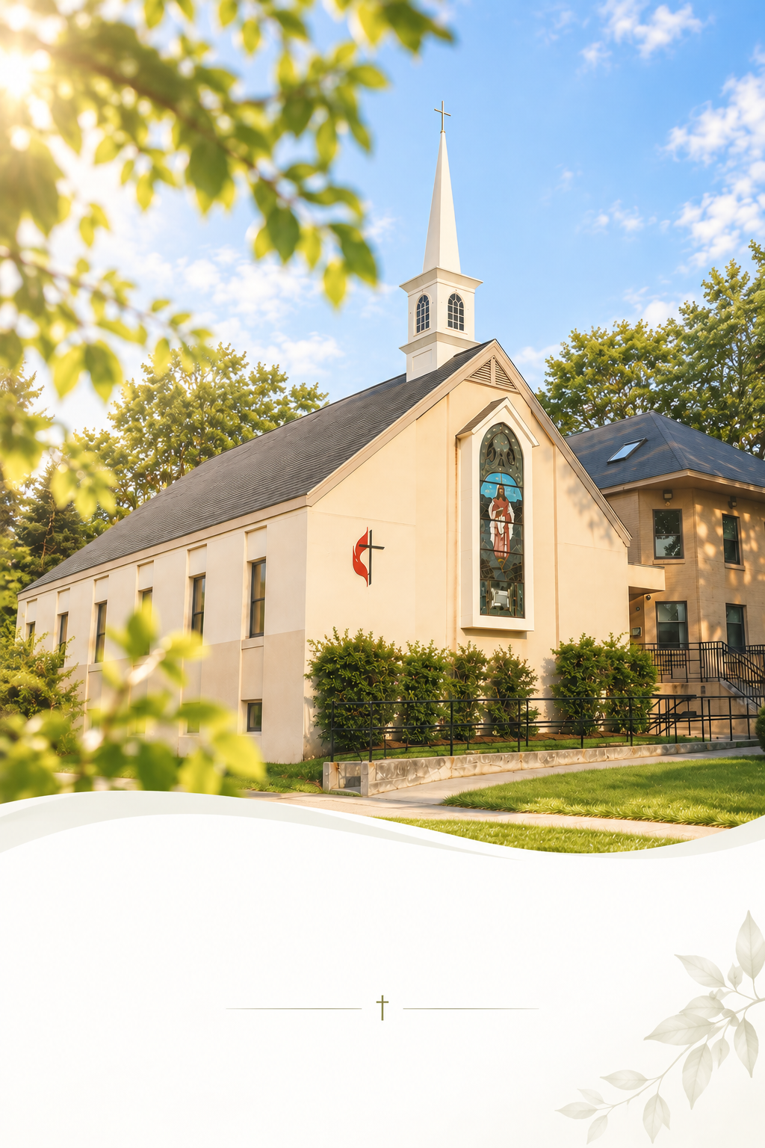

October 25, 2026
Sunday Worship 10:30AM

Faith in Action

Mission Statement
We act as disciples for Christ by freely sharing our resources with our community and by serving those who are lonely and in need. We support each other in growing our faith and seeking meaningful ways to share God’s grace with more people.

- Every 1st Sat @ 8:30 AM: Men’s Walk & Breakfast

- Every Sun. 9:40 AM: Music Rehearsal. Anyone who can play an instrument or sing can join us!

- You are invited to our coffee hour in the fellowship downstairs!
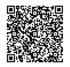
- Online Offering is available! Take a picture of the QR code, or visit give.tithe.ly and search for “United Methodist Church of Newton -430 Walnut St, Newtonville.”

- Need a prayer? Please remain in the sanctuary after the service. The pastor will pray with you.

- Want to be a member of the church? Talk to the pastor.

- First Free Public Seminar by Newton-Boston Korean United Methodist Church - "Understanding Alzheimer’s disease and related dementias” by Hyun-Sik Yang, MD.
In Korean - Sun. Oct 25. 2:30 PM.
In English - Sun. Nov 8. 2:30 PM.

- Kimchi Making Event – Sat. Nov 7, 10:30 AM.

- 2026 Church Conference – Wed. Nov 11th. 7 PM (800 Highland Ave, Needham, MA 02494)

Faith in Action

Mission Statement
We act as disciples for Christ by freely sharing our resources with our community and by serving those who are lonely and in need. We support each other in growing our faith and seeking meaningful ways to share God’s grace with more people.

- Every 1st Sat @ 8:30 AM: Men’s Walk & Breakfast

- Every Sun. 9:40 AM: Music Rehearsal. Anyone who can play an instrument or sing can join us!

- You are invited to our coffee hour in the fellowship downstairs!
- Online Offering is available! Take a picture of the QR code, or visit give.tithe.ly and search for “United Methodist Church of Newton -430 Walnut St, Newtonville.”

- Need a prayer? Please remain in the sanctuary after the service. The pastor will pray with you.

- Want to be a member of the church? Talk to the pastor.

- First Free Public Seminar by Newton-Boston Korean United Methodist Church - "Understanding Alzheimer’s disease and related dementias” by Hyun-Sik Yang, MD.
In Korean - Sun. Oct 25. 2:30 PM.
In English - Sun. Nov 8. 2:30 PM.

- Kimchi Making Event – Sat. Nov 7, 10:30 AM.

- 2026 Church Conference – Wed. Nov 11th. 7 PM (800 Highland Ave, Needham, MA 02494)

