- *Greetings
- *Gathering Music
TFWS #2025, As the Deer

- As the deer panteth for the water, So my soul longeth after Thee. You alone are my heart's desire, And I long to worship Thee.

[refrain] You alone are my strength, my shield. To You alone may
my spirit yield. You alone are my heart's desire. And I long to worship Thee.

- You're my friend, and You are my brother Even though You are a King. I love You more than any other So much more than anything [refrain].

He's Got the Whole World in His Hands

(1) He's got the whole world in his hands (x4).
(2) He's got the wind and the rain in his hands (x3).
He's got the whole world in his hands.
(3) He's got the little tiny baby in his hands (x3).
He's got the whole world in his hands.
(4) He's got you and me, brother, in his hands (x3).
He's got the whole world in his hands.
(5) He's got you and me, sister, in his hands (x3).
He's got the whole world in his hands.
(6) He's got everybody here in his hands (x3).
He's got the whole world in his hands.

- *Call to Worship
Leader: The apostle Paul calls us to “let the same mind be in you that was in Christ Jesus.” What is the mind of Jesus?
People: The mind of Jesus is to love God, neighbor, self, and all creation.

Leader: Paul reminds us that “it is God who is at work in you.” How is God at work in us?
People: God enables us through grace to love God, neighbor, self, and all creation.

Leader: Paul exhorts us to “work on your own salvation with fear and trembling.” How do we work on our own salvation?
People: We cooperate with grace to love God, neighbor, self, and all creation.

Leader: Beloved, we gather to worship God who, through Jesus, shows us how to love and enables us to love as Christ loves us.
People: We gather to learn how to live in full accord through our love of God, neighbor, self, and all creation.

- Prayer of Confession & Words of Assurance
Holy God, we know that in so many ways
We have run from you,
We have ignored your call,
We have closed our eyes to your presence,
We have disbelieved your mercy,
We have disregarded your words,
We have belittled ourselves,
We have forsaken others.
So we ask, once again, for your forgiveness.
We ask you to stay with us as we turn away from what is wrong and hurtful
to what is bright and life-giving.

Our God is merciful and generous, and ready to forgive us and embrace. We are forgiven in the name of Jesus Christ. Hallelujah, Amen!

- *Hymn UMH #432, Jesu, Jesu

[Refrain] Jesu, Jesu, fill us with your love,
show us how to serve the neighbors we have from you.

1. Kneels at the feet of his friends, silently washes their feet,
Master who acts as a slave to them. (Refrain)
2. Neighbors are rich and poor, neighbors are black and white,
neighbors are near and far away. (Refrain)
3. These are the ones we should serve, these are the ones we should love;
all these are neighbors to us and you. (Refrain)
4. Loving puts us on our knees, serving as though we are slaves,
this is the way we should live with you. (Refrain)
5. Kneel at the feet of our friends, silently washing their feet,
this is the way we should live with you. (Refrain)

- Faith in Action (see the insert)

- Scripture Lesson Philippians 2:1-13

- Children’s Time
(As children come forward) “Yes, Jesus loves us (x3). The Bible tells us so.”
(As children return) “God is watching over you…each day.”

- Sermon “True Humility” Pastor Sunmin

- *Offering UMH #94, Praise God from Whom All Blessings Flow
Praise God from whom all blessings flow; Praise God, all creatures here below: Alleluia! Alleluia! Praise God, the source of all our gifts! Praise Jesus Christ, whose power uplifts! Praise the Spirit, Holy Spirit! Alleluia! Alleluia! Alleluia!

- *Prayer of Dedication
Humble Savior, you meet us at the start of every day and invite us to take on the mind of Christ. As we bring these gifts, set aside in us the need to win, to hoard, to be first. Shape us instead for love, for shared work, for joy in serving side by side. Use what we offer to build a community where sacrifice is natural, mercy is instinctive, and hope rises in every heart. Amen.

- Prayer Concern
“Lord, in Your Mercy, Hear Our Prayer.”

- Pastoral Prayer & the Lord’s Prayer

- *Hymn of Your Choice (First Shout, First Sung basis)


- *Benediction & Postlude

The United Methodist Church of Newton
430 Walnut St., Newton, MA 02460 | 617-244-0275

September 27, 2026
Sunday Worship 10:30AM

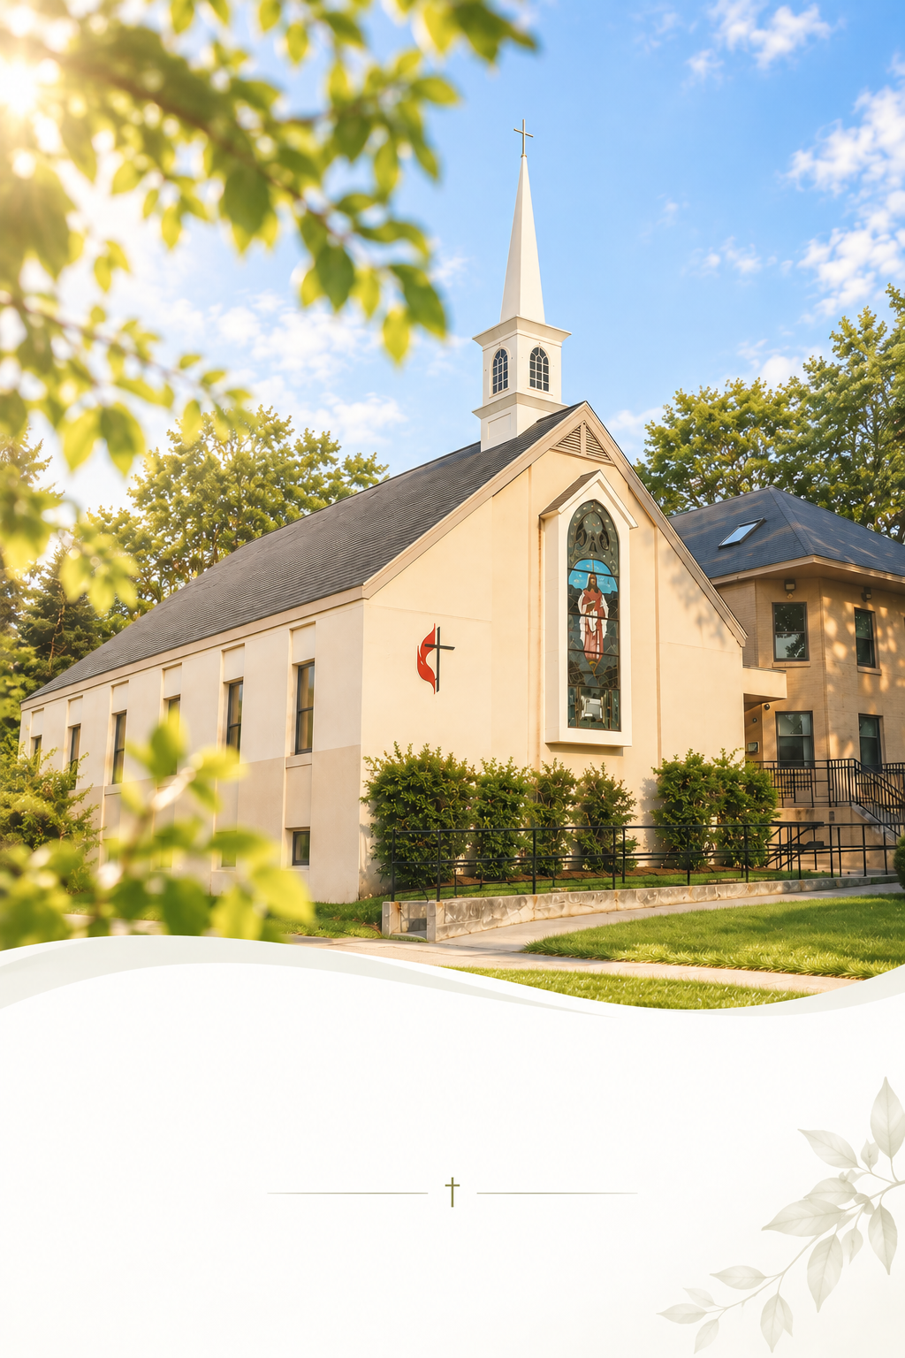

Faith in Action

Mission Statement
We act as disciples for Christ by freely sharing our resources with our community and by serving those who are lonely and in need. We support each other in growing our faith and seeking meaningful ways to share God’s grace with more people.

- Every 1st Sat @ 8:30 AM: Men’s Walk & Breakfast

- Every Sun. 9:40 AM: Music Rehearsal. Anyone who can play an instrument or sing can join us!

- You are invited to our coffee hour in the fellowship downstairs!

- Online Offering is available! Take a picture of the QR code, or visit give.tithe.ly and search for “United Methodist Church of Newton -430 Walnut St, Newtonville.”

- Need a prayer? Please remain in the sanctuary after the service. The pastor will pray with you.

- Want to be a member of the church? Talk to the pastor.

- 2026 Annual Conference – Wed. Nov 11th. 7 PM (800 Highland Ave, Needham, MA 02494)
- Special Charge Conference – Next Sunday, Oct 4. After the service.

- Lunch with Kimchi – Sat. Oct 3 @ 11 am. Please sign up!

Faith in Action

Mission Statement
We act as disciples for Christ by freely sharing our resources with our community and by serving those who are lonely and in need. We support each other in growing our faith and seeking meaningful ways to share God’s grace with more people.

- Every 1st Sat @ 8:30 AM: Men’s Walk & Breakfast

- Every Sun. 9:40 AM: Music Rehearsal. Anyone who can play an instrument or sing can join us!

- You are invited to our coffee hour in the fellowship downstairs!
- Online Offering is available! Take a picture of the QR code, or visit give.tithe.ly and search for “United Methodist Church of Newton -430 Walnut St, Newtonville.”

- Need a prayer? Please remain in the sanctuary after the service. The pastor will pray with you.

- Want to be a member of the church? Talk to the pastor.

- 2026 Annual Conference – Wed. Nov 11th. 7 PM (800 Highland Ave, Needham, MA 02494)
- Special Charge Conference – Next Sunday, Oct 4. After the service.

- Lunch with Kimchi – Sat. Oct 3 @ 11 am. Please sign up!

